0

**Web Development Full Stack**

**Summer Internship Report**

Submitted in partial fulfillment of the requirement of the degree of

Bachelor of Technology

in

Computer Science and Engineering

By

**Manas Pandey – 01296302717**

****

Maharaja Surajmal Institute of Technology

(Affiliated to Guru Gobind Singh Indraprastha University)

Janakpuri, New Delhi – 58

**Declaration**

I Manas Pandey (Enrollment number : 01296302717) currently in 5th semester pursuing Bachelor of technology in Computer Science from Maharaja Surajmal Institute Of Technology, New Delhi hereby declare that the “Summer Training Report on Music Player “ is my original work and all the report breach no copyright or license , and are created by me on my own, or using resources that I have complete permission to use. All the data given in this report is authentic to the best of my knowledge, and this report has not been submitted to any institute for the award of any other degree.

Manas Pandey

01296302717

Maharaja Surajmal Institute Of Technology

October 2019

**Cerificate**



**Certificate From Organization**

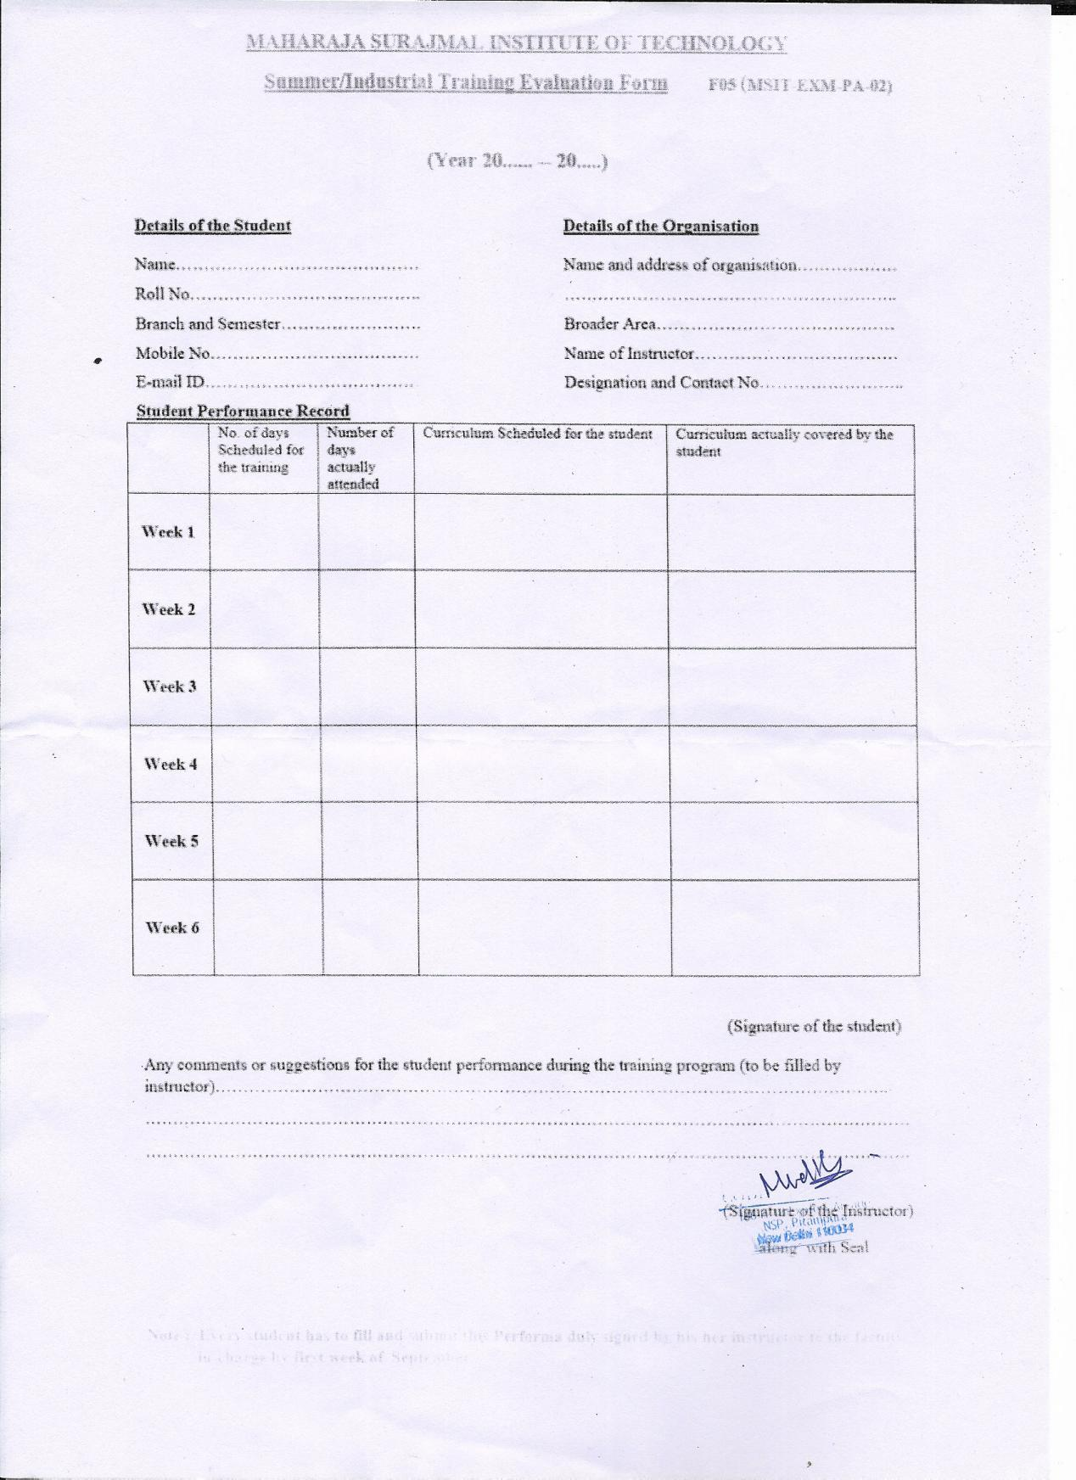

**ACKNOWLEDGEMENT**

I would like to acknowledge Dr. Naveen Dahiya for providing us with such a great opportunity to work with real life projects and gaining professional experience.

I would like to express my gratitude to Mudit Goel Sir for guiding me throughout this wonderful project and inducing great knowledge around web development full stack.

I would also like to acknowledge my parents, because it was their utter belief and continuous support which motivated me to complete this project.

This opportunity is a big milestone in my life and career. It has taught me all those things that I only used to give a thought on. I will strive to use the gained skill and knowledge in the best and effective way possible.

**Music Player**

**Abstract**

Music Player or Audio Player is one of most popular and easy way to listen to music and relax.They fall under the category of media players along with video players and are used to play audio files from the system media. Media players commonly display standard media control icons known from physical devices such as tape recorders and CD players, such as play ( [IMG_256](https://en.wikipedia.org/wiki/File:Octicons-playback-play.svg) ), pause ( [IMG_257](https://en.wikipedia.org/wiki/File:Octicons-playback-pause.svg) ), fast-forward, back-forward buttons. In addition, they generally have progress bars (or "playback bars") to locate the current position in the duration of the media file.Winamp media player was one of the earliest fores into the digital music player.It was initially released in 1997 and was written in C/C++ programming language.It was the inspiration and the spark that kick started the digital media player market.

Are you looking for fun and entertainment while you are at your leisure time? Then perhaps the best thing that you can do is to listen to music. It not only provides a feeling of relaxation but also soothes the mind from all the worries and anxiety that you may be experiencing. But, what is the best tool that you can use in order to listen to your favorite songs? I recommend to you the music player.

The music player is an online application that is available for a free download. You simply need to install this on your device which is most likely your mobile phone or your laptop. It is basically a software wherein you can store all your music collection. Here, you can organize all the songs and tunes that you have according to your preference. And you can play them anywhere and anytime you desire. This is indeed the perfect tool for all your music needs

**List Of Figures**

|  |  |
| --- | --- |
| **Figure Number** | **Description** |
| **1.1** | **Coding Blocks Logo** |
| **1.2** | **Mudit Goel** |
| **1.3** | **Location Map** |
| **2.1** | **HTML Logo** |
| **2.2** | **CSS Logo** |
| **2.3** | **Git Logo** |
| **2.4** | **JavaScript Logo** |
| **2.5** | **ReactJS Logo** |
| **2.6** | **MobX Logo** |
| **2.7** | **MobX Process** |
| **2.8** | **NodeJS Logo** |
| **2.9** | **Express Logo** |
| **2.10** | **WebSocket Logo** |

|  |  |
| --- | --- |
| **2.11** | **FireBase Logo** |
| **2.12** | **PostgreSQL Logo** |
| **2.13** | **jQuery Logo** |
| **2.14** | **Ajax Logo** |
| **2.15** | **Visual Studio Code Logo** |
| **2.16** | **Xampp Logo** |
| **2.17** | **Heroku Logo** |
| **3.1** | **Process Diagram** |
| **4.1** | **Homepage** |
| **4.2** | **Seek Bar** |
| **4.3** | **Volume Bar** |
| **4.4** | **Mute** |
| **4.5** | **Unmute** |
| **4.6** | **Play** |
| **4.7** | **Pause** |
| **4.8** | **Repeat Song** |
| **4.9** | **Repeat Shuffle** |
| **4.10** | **Repeat Playlist** |
| **4.11** | **Playlist** |
| **4.12** | **Download List** |
| **4.13** | **Download Window** |

**Table of Contents**

1. Company Profile…………………………………………….1
   1. Coding Elements……………………………………….1
   2. About Founder…………………………………………2
   3. Courses at Coding Elements…………………………...3
   4. Location on Map……………………………………….3
2. Technology Tools Studied…………………………………..4

2.1 HTML……………………………………………….....4

2.2 CSS……………………………………………………..5

2.3 Version Control - git……………………………………6

2.4 JavaScript……………………………………………….7

2.5 ReactJS………………………………………………….8

2.6 Lifecyle Methods……………………………………….9

2.7 MobX

2.8 NodeJS

2.9 Express

2.10 Websocket

2.11 Google Cloud Platform

2.12 PostgreSQL

2.13 jQuery

2.14 Ajax

2.15 Visual Studio Code

2.16 Xampp

2.17 Heroku

3. Problem Statement,SRS,Diagrams

3.1 Problem Statement

3.2 System Requirement Specification (SRS)

3.2.1 Introduction

3.2.2 Overview

3.2.2.1 Customers

3.2.2.2 Functionality

3.2.2.3 Platform

3.2.2.4 Development Responsibility

3.2.3 Deliverables

3.2.4 Risk Management

3.2.4.1 Risk Identification

3.2.4.2 Risk Mitigation

3.2.5 Technical Process

3.3 Diagram

4.Interface

4.1 Home Page

4.2 Seek Bar

4,3 Volume Bar

4.4 Mute/Unmute

4.5 Play/Pause

4.6 Repeat

4.6.1 Repeat Playlist

4.6.2 Repeat Song

4.6.3 Repeat Shuffle

4.7 Playlist

4.8 Download

4.9 Heroku Site Hosting

5.Conclusion

6Bibliography

**Chapter-1 Company Profile**

**1.1 Coding Elements**



Fig 1.1

* Company Name – CODING ELEMENTS
* Established in – 2017
* Address - H-10 Express Arcade Netaji Subash Place Suite 106, Netaji Subhash Place, Wazirpur, Delhi, 110034
* Email id :-info@codingelements.com
* Phone No 9999643211
* Head Quarter – New Delhi
* Size – 1 to 50 employees
* Type – Private
* Industry – Education training services
* Top rated institute for learning programming languages in Delhi NCR. Faculty from USA, with experience at top companies in Silicon Valley.
* Since 2017, Coding Elements in GTB Nagar, Delhi has been offering professional training to students. It specialises and is well-known for training students as well as working professionals in accounting, web designing, programming languages, hardware and networking. It is run and managed by a seasoned professionals who leads a team of educators and trainers having relevant domain expertise. At this institution, one can get trained in the subject of their choice by opting from a wide range of courses. These easy-to-follow courses are primarily aimed at students, working professionals as well as IT professionals who want to enhance their knowledge and further their career prospects. Located Hudson Lane, you can find this institution with relative ease at Shop Number-25 in GTB Nagar. Undoubtedly it is one of the best computer training institutes in GTB Nagar, Delhi.
* Faculty from US with experience at top companies like: LinkedIn,Amazon,IBM

**1.2 About Founder**



Mudit has experience at top Software companies like LinkedIn. He has served as a member of the Hiring Committee at top companies in Silicon Valley and conducted over 400 interviews. He got his CS degree from New York and worked in San Francisco, California for 5 years.

Mudit has experience at top Software companies like LinkedIn. He has served as a member of the MUDIT GOEL Hiring Committee at top companies in Silicon Fig- 1.2 Valley and conducted over 400 interviews. He got his CS degree from New York and worked in San Francisco, California for 5 years.

* 1. **Courses at Coding Elements**

1. Online Courses

1.1 Python For Data Science

* 1. Mobile App Development With React

2.Offline Courses

2.1Data Structures And Algorithm In Java

2.2Python For Data Science

2.3Full Stack Web Development

2.4Machine Learning And Deep Learning

2.5Android App Development

2.6Mobile App Development With React

2.7Coding Interview Preparation

2.8Coding For School Students

**1.4 Location on map**

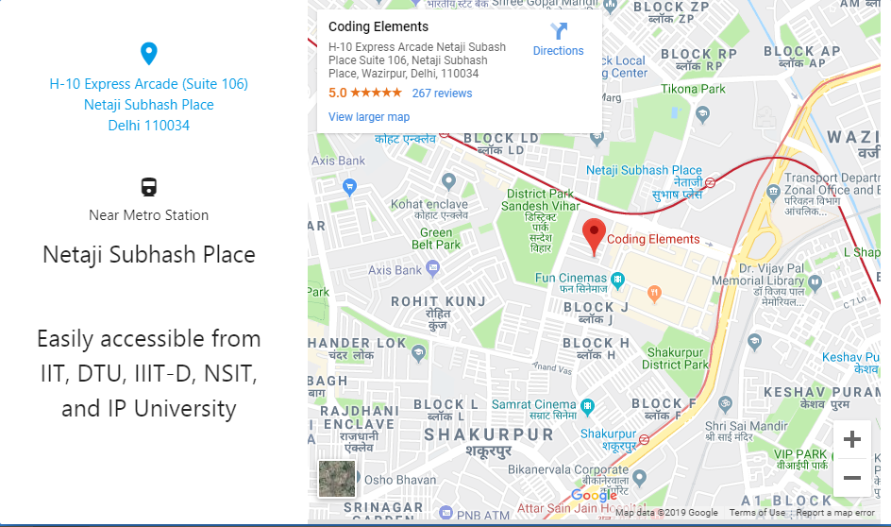

Fig- 1.3

**Chapter- 2 Technology Tools Studied**

**2.1 HTM**

Fig 2.1

Hypertext Markup Language (HTML) is the standard markup language for documents designed to be displayed in a web browser. It can be assisted by technologies such as Cascading Style Sheets (CSS) and scripting languages such as Java Script.

Web browsers receive HTML documents from a web servers or from local storage and render the documents into multimedia web pages. HTML describes the structure of a web page semantically and originally included cues for the appearance of the document.

**2.2 CSS**

**Fig 2.2**

Cascading Style Sheets (CSS) is a style sheet language used for describing the presentation of a document written in a markup language like HTML.CSS is a cornerstone technology of the World Wide Web, alongside HTML and JavaScript

CSS is designed to enable the separation of presentation and content, including layout, colors, and fonts.This separation can improve content accessibility, provide more flexibility and control in the specification of presentation characteristics, enable multiple web pages to share formatting by specifying the relevant CSS in a separate .css file, and reduce complexity and repetition in the structural content.

**2.3 Version Control - Git**

IMG_256

Fig 2.3

**Git** is a distributed version control system for tracking changes in code during software development.It is designed for coordinating work among programmers, but it can be used to track changes in any set of files. Its goals include speed, data integrity, and support for distributed, non-linear work flows.

Git was created by Linus Trovalds in 2005 for development of the Linux kernel, with other kernel developers contributing to its initial development.Its current maintainer since 2005 is Junio Hamano. As with most other distributed version-control systems, and unlike most client-server systems, every Git directory on every computer is a full-fledged repository with complete history and full version-tracking abilities, independent of network access or a central server.Git is free and open-source software distributed under the terms of the GNU General Public License version 2.

**2.4 JavaScript**

Fig 2.4

JavaScript often abbreviated as JS, is a high-level, interpreted scripting language that conforms to the ECMAScript specification. JavaScript has curly-bracket syntax, dynamic typing, prototype-based object-orientation, and first-class functions.

Alongside HTML and CSS, JavaScript is one of the core technologies of the World Wide Web.JavaScript enables interactive web pages and is an essential part of web applications. The vast majority of websites use it, and major web browsers have a dedicated JavaScript Engine to execute it.

As a multi-paradigm language, JavaScript supports event-driven, functional, and imperative (including object-oriented and prototype-based) programming styles. It has APIs for working with text, arrays, dates, regular expressions, and the DOM, but the language itself does not include any I/O, such as networking, storage, or graphics facilities. It relies upon the host environment in which it is embedded to provide these features.

**2.5 ReactJS (Frontend)**

Fig 2.5

React (also known as React.js or ReactJS) is a JavaScript Library for building user interfaces. It is maintained by Facebook and a community of individual developers and companies.

React can be used as a base in the development of single-page or mobile applications, as it is optimal for fetching rapidly changing data that needs to be recorded. However, fetching data is only the beginning of what happens on a web page, which is why complex React applications usually require the use of additional libraries for state management, routing, and interaction with an API: Next.js and Gatsby.js are examples of such libraries.

**2.6 Lifecycle Method**

Lifecycle methods are hooks that allow execution of code at set points during a component's lifetime.

* shouldComponentUpdate allows the developer to prevent unnecessary re-rendering of a component by returning false if a render is not required.
* componentDidMount is called once the component has "mounted" (the component has been created in the user interface, often by associating it with a DOM node). This is commonly used to trigger data loading from a remote source via an API.
* componentWillUnmount is called immediately before the component is torn down or "unmounted". This is commonly used to clear resource demanding dependencies to the component that will not simply be removed with the unmounting of the component (e.g., removing any setInterval() instances that are related to the component, or an "eventListner" set on the "document" because of the presence of the component)
* render is the most important lifecycle method and the only required one in any component. It is usually called every time the component's state is updated, which should be reflected in the user interface.

**2.7 MobX**

**Fig 2.6**

MobX is a battle tested library that makes state management simple and scalable by transparently applying functional reactive programming (TFRP). The philosophy behind MobX is very simple:

*Anything that can be derived from the application state, should be derived. Automatically.*

which includes the UI, data serialization, server communication, etc.

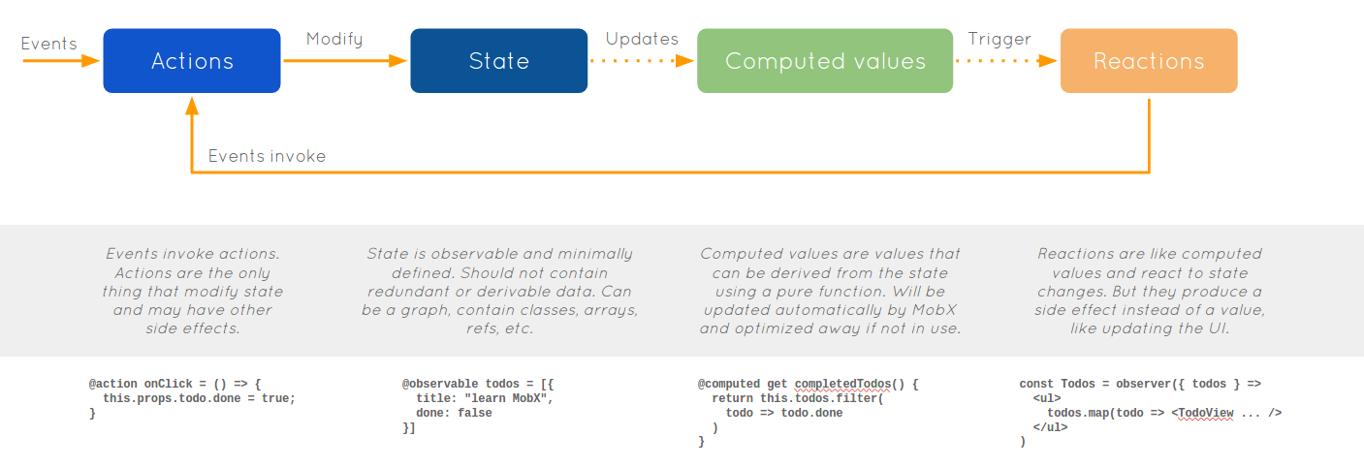Fig 2.7

React and MobX together are a powerful combination. React renders the application state by providing mechanisms to translate it into a tree of renderable components. MobX provides the mechanism to store and update the application state that React then uses.

**2.8 NodeJS(Backend)**

Fig 2.8

Node.js is an open-source, cross-platform, JavaScript run-time environment that executes JavaScript code outside of a browser. Node.js lets developers use JavaScript to write command line tools and for server-side scripting—running scripts server-side to produce dynamic web page content before the page is sent to the user's web browser. Consequently, Node.js represents a "JavaScript everywhere" paradigm, unifying web application development around a single programming language, rather than different languages for server- and client-side scripts.

Though .js is the standard filename extension for JavaScript code, the name "Node.js" does not refer to a particular file in this context and is merely the name of the product. Node.js has an event-driven architecture capable of asynchronous I/.O These design choices aim to optimize throughput and scalability in web applications with many input/output operations, as well as for real-time Web applications (e.g., real-time communication programs and browser games).

The Node.js distributed development project, governed by the Node.js Foundation, is facilitated by the Linux Foundation’s Collaborative Projects program.

**2.9 Express**

Fig 2.9

Express is a minimal and flexible Node.js web application framework that provides a robust set of features to develop web and mobile applications. It facilitates the rapid development of Node based Web applications. Following are some of the core features of Express framework −

* Allows to set up middlewares to respond to HTTP Requests.
* Defines a routing table which is used to perform different actions based on HTTP Method and URL.
* Allows to dynamically render HTML Pages based on passing arguments to templates.

**Installing Express**

Firstly, install the Express framework globally using NPM so that it can be used to create a web application using node terminal.

$ npm install express --save

The above command saves the installation locally in the node\_modules directory and creates a directory express inside node\_modules. You should install the following important modules along with express −

$ npm install body-parser --save

$ npm install cookie-parser --save

$ npm install multer --save

**2.10 Websocket**

****

Fig 2.10

The WebSocket protocol enables interaction between a web browsers (or other client application) and a web servers with lower overhead than half-duplex alternatives such as HTTP polling, facilitating real-time data transfer from and to the server. This is made possible by providing a standardized way for the server to send content to the client without being first requested by the client, and allowing messages to be passed back and forth while keeping the connection open. In this way, a two-way ongoing conversation can take place between the client and the server. The communications are done over TCP port number 80 (or 443 in the case of TLS-encrypted connections), which is of benefit for those environments which block non-web Internet connections using a firewall. Similar two-way browser-server communications have been achieved in non-standardized ways using stopgap technologies such as Comet.

**2.11 Google Cloud Platform (Backend)**

Fig 2.11

Google Firebase is a Google-backed application development software that enables developers to develop iOS, Android and Web apps. Firebase provides tools for tracking analytics, reporting and fixing app crashes, creating marketing and product experiment. Firebase offers a number of services, including:

**Analytics** – Google Analytics for Firebase offers free, unlimited reporting on as many as 500 separate events. Analytics presents data about user behavior in iOS and Android apps, enabling better decision-making about improving performance and app marketing.

**Authentication** – Firebase Authentication makes it easy for developers to build secure authentication systems and enhances the sign-in and onboarding experience for users. This feature offers a complete identity solution, supporting email and password accounts, phone auth, as well as Google, Facebook, GitHub, Twitter login and more.

**Realtime database** – the Firebase Realtime Database is a cloud-hosted NoSQL database that enables data to be stored and synced between users in real time.The data is synced across all clients in real time and is still available when an app goes offline.

**Crashlytics** – Firebase Crashlytics is a real-time crash reporter that helps developers track, prioritize and fix stability issues that reduce the quality of their apps. With crashlytics, developers spend less time organizing and troubleshooting crashes and more time building features for their apps.

**Test lab** – Firebase Test Lab is a cloud-based app-testing infrastructure. With one operation, developers can test their iOS or Android apps across a variety of devices and device configurations. They can see the results, including videos, screenshots and logs, in the Firebase console.

**2.12 PostgreSQL**

**Fig 2.12**

PostgreSQL, also known as Postgres, is a free and open-source relational database management system (RDBMS) emphasizing extensibility and technical standards compliance. It is designed to handle a range of workloads, from single machines to data warehouses or Web services with many concurrent users. It is the default database for macOS Server,and is also available for Linux, FreeBSD, OpenBSD, and Windows.

PostgreSQL features transactions with Atomicity, Consistency, Isolation, Durability (ACID) properties, automatically updatable [views](https://en.wikipedia.org/wiki/View_(SQL)" \o "View (SQL)), materialized views, triggers, foreign keys, and stored procedures. PostgreSQL is developed by the PostgreSQL Global Development Group, a diverse group of many companies and individual contributors.

**2.13 jQuery**

****

Fig 2.13

**jQuery** is a JavaScript library designed to simplify HTML DOM tree traversal and manipulation, as well as event handling, CSS animation, and Ajax. It is free, open-source software using the permissive MIT License. As of May 2019, jQuery is used by 73% of the 10 million most popular websites. Web analysis indicates that it is the most widely deployed JavaScript library by a large margin, having 3 to 4 times more usage than any other JavaScript library. jQuery's syntax is designed to make it easier to navigate a document, select DOM elements, create animations, handle events, and develop Ajax applications. jQuery also provides capabilities for developers to create plug-ins on top of the JavaScript library. This enables developers to create abstractions for low-level interaction and animation, advanced effects and high-level, theme able widgets. The modular approach to the jQuery library allows the creation of powerful dynamic web pages and Web applications.

**2.14 Ajax**

****

Fig 2.14

**Ajax** (also **AJAX** short for asynchronous JavaScript and XML) is a set of web development techniques using many web technologies on the client side to create asynchronous web applications. With Ajax, web applications can send and retrieve data from a server asynchronously (in the background) without interfering with the display and behaviour of the existing page. By decoupling the data interchange layer from the presentation layer, Ajax allows web pages and, by extension, web applications, to change content dynamically without the need to reload the entire page. In practice, modern implementations commonly utilize JSON instead of XML.

Ajax is not a single technology, but rather a group of technologies. HTML and CSS can be used in combination to mark up and style information. The webpage can then be modified by JavaScript to dynamically display—and allow the user to interact with—the new information. The built-in XMLHttpRequest object, or since 2017 the new "fetch()" function within JavaScript is commonly used to execute Ajax on webpages allowing websites to load content onto the screen without refreshing the page. Ajax is not a new technology, or different language, just existing technologies used in new ways.

**2.15 Visual Studio Code**



Fig 2.15

**\Visual Studio Code** is a source-code editor developed by Microsoft for Windows, Linux and macOS. It includes support for debugging, embedded Git control and GitHub, syntax highlighting, intelligent code completion, snippets, and code refactoring. It is highly customizable, allowing users to change the theme, keyboard shortcuts, preferences, and install extensions that add additional functionality. The source code is free and open source and released under the permissive MIT License. The compiled binaries are freeware and free for private or commercial use. Visual Studio Code is based on Electron, a framework which is used to deploy Node.js applications for the desktop running on the Blink layout engine. Although it uses the Electron framework, the software does not use Atom and instead employs the same editor component (codenamed "Monaco") used in Azure DevOps (formerly called Visual Studio Online and Visual Studio Team Services).

**2.16 XAMPP**

 Fig 2.16

**XAMPP** is a free and open-source cross-platform web server solution stack package developed by Apache Friends, consisting mainly of the Apache HTTP Server, MariaDB database, and interpreters for scripts written in the PHP and Perl programming languages. Since most actual web server deployments use the same components as XAMPP, it makes transitioning from a local test server to a live server possible.

XAMPP's ease of deployment means a WAMP or LAMP stack can be installed quickly and simply on an operating system by a developer. With the advantage a number of common add-in applications such as WordPress and Joomla! can also be installed with similar ease using Bitnami.

The term XAMPP is an apparent acronym. However, there is no official acronym expansion specified on the Apache Friends website. Their homepage header reads "XAMPP Apache + MariaDB + PHP + Perl", indicating that this abbreviation is a recursive acronym.

XAMPP is regularly updated to the latest releases of Apache, MariaDB, PHP and Perl. It also comes with a number of other modules including OpenSSL, phpMyAdmin, MediaWiki, Joomla, WordPress and more. Self-contained, multiple instances of XAMPP can exist on a single computer, and any given instance can be copied from one computer to another.

**2.17 Heroku**

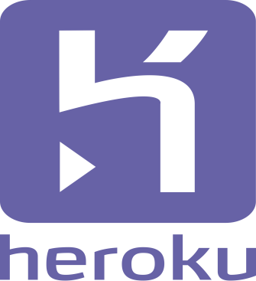

**Fig 2.17**

Heroku is a cloud platform as a service (PaaS) supporting several programming languages. One of the first cloud platforms, Heroku has been in development since June 2007, when it supported only the Ruby programming language, but now supports Java, Node.js, Scala, Clojure, Python, PHP, and Go.For this reason, Heroku is said to be a polyglot platform as it has features for a developer to build, run and scale applications in a similar manner across most languages.

The Heroku Command Line Interface (CLI) makes it easy to create and manage your Heroku apps directly from the terminal. It’s an essential part of using Heroku.The Heroku CLI requires Git, the popular version control system.

**Chapter-3 Problem Statement,SRS,Diagrams**

**3.1 Problem Statement**

Ideally the users would be able to listen to songs in the music player and create and listen to their own playlist from a database of songs that would work as a music library.

Due to licensing problems the library has to be populated manually of songs and album covers.The future updates and releases are expected to populate a bigger library and creation of custom playlists .Furthermore internet radio will be added to the Muvaudio music player in future release.Login and playlist population through Soundcloud and Google is to be implemented in future.

**3.2 Software Requirement Specification (SRS)**

**3.2.1 Introduction**

The intended readers of this document are current and future developers working on “Muvaudio”. The plan will include, but is not restricted to, a summary of the system functionality,the scope of the project from the perspective of the Application team (me and my mentors),scheduling and delivery estimates, project risks and how those risks will be mitigated, the process by which I will develop the project, and metrics and measurements that will be recorded throughout the project.

**3.2.2 Overview**

In today’s world, owning to the hectic and engaging lifestyles, people have huge amount of stress in their lives. Even with the presence of so many gadgets in and around them, they are not able to relieve their stress. I aim to develop an application that would enable them to relax and detach themselves from their problems while using my application.

**3.2.2.1 Customers**

Everyone. Anyone can use this application ranging from a child to an old-age person.

**3.2.2.2 Functionality**

* *Users should be able to register through their Google accounts.*
* Listen to music
* *Add and share songs and playlists*
* Download songs
* *Create custom playlist*
* *Movie upload,download and streaming*

P.S. Italic point’s features can be inculcated later.

**3.2.2.3 Platform**

It will be launched as a website ; Android and iOS apps will be launched in the future.

**3.2.2.4 Development Responsibility**

I, Manas Pandey would be developing the software and I am responsible for the creation of the Database and all the other related components.

**3.2.3 Deliverables**

The following will be delivered during the course of development:

* • Feature specification
* • Product design
* • Test plan
* • Development document
* • Source code

**3.2.4 Risk Management**

**3.2.4.1** **Risk Identification**

Following will be the risk involved in my project:

1. People are already using JioSaavn,Wynk,Soundcloud etc to listen to music. So, what would be the real cause that would motivate them to join my app?

**3.2.4.2 Risk Mitigation**

Even though most of the users would already be usingJioSaavn,Wynk,Soundcloud etc, our platform would still offer them many things that is not there on already available applications. For eg.

1. It will act as a combined hub for both audio and video entertainment at one location.

**3.2.5 Technical Process**

Following would be the languages I would use to develop my application within the

stipulated time period:

HTML,CSS,jQuery,php and JavaScript

**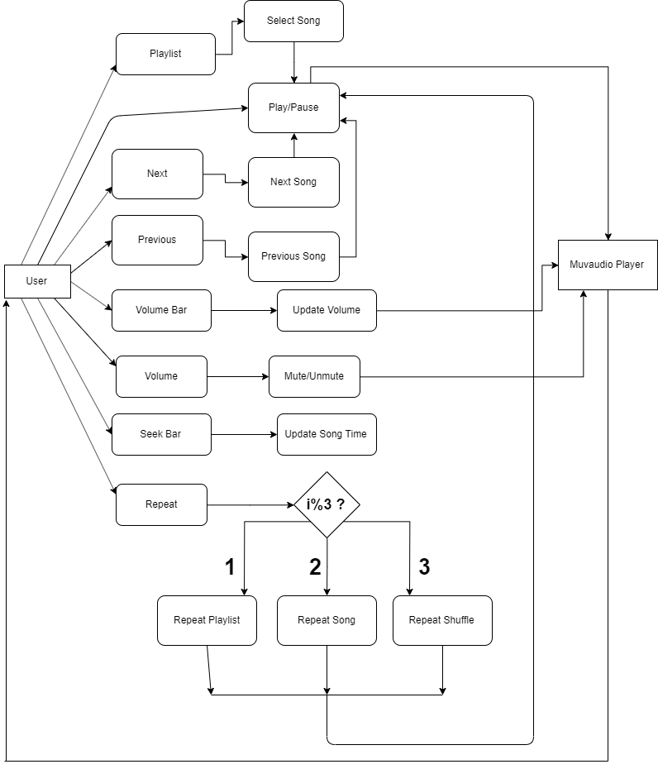3.3 Diagrams**

**Fig 3.1**

**Chapter 4-Interface**

**4.1 Home Page**

A home page is a webpage that serves as the starting point of website. It is the default webpage that loads when you visit a web address that only contains a domain name.

The home page is located in the root directory of a website. Most web server allow the home page to have one of several different filenames. Examples include index.html, index.htm, index.shtml, index.php, default.html, and home.html. The default filename of a website's home page can be customized on both Apache and IIS servers. Since the home page file is loaded automatically from the root directory, the home page URL does not need need to include the filename.

The Homepage in itself presents the music player.The player is programmed to run the player as soon as the window is loaded.On refreshing the page the player reloads and resets all the function s and butons to the default states.The player is set to move to the first index of the playlist whenever the page is refreshed.

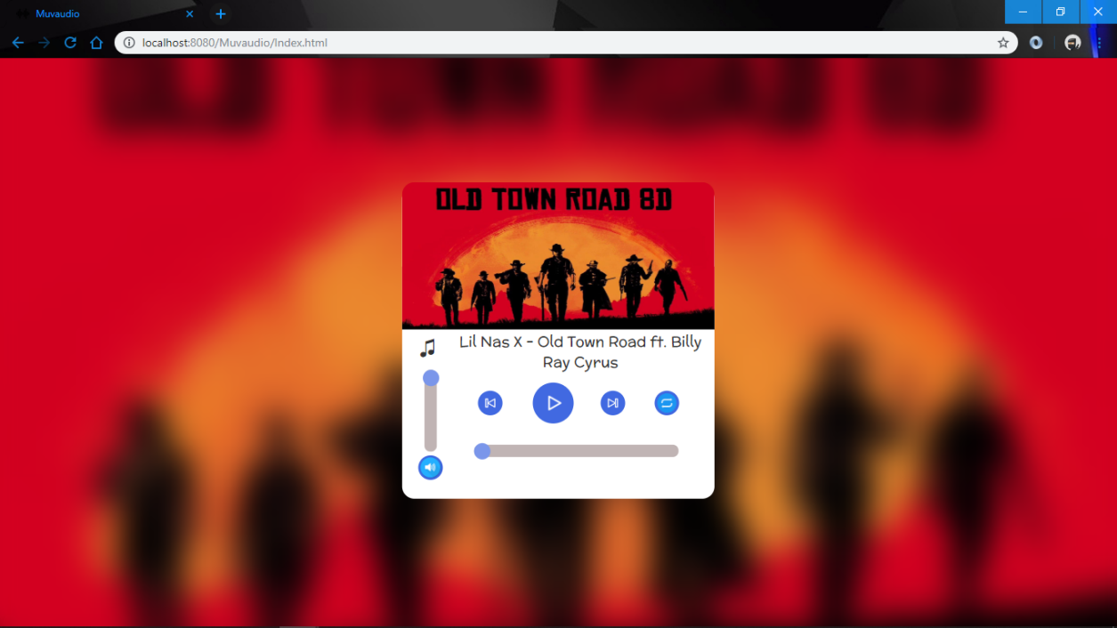

**Fig 4.1**

**4.2 Seek Bar**

A SeekBar is an extension of ProgressBar that adds a draggable thumb. The user can touch the thumb and drag left or right to set the current progress level or use the arrow keys.You must have seen a bar with your media player (audio or video). It helps you to navigate to a certain time of the audio or video you are using.

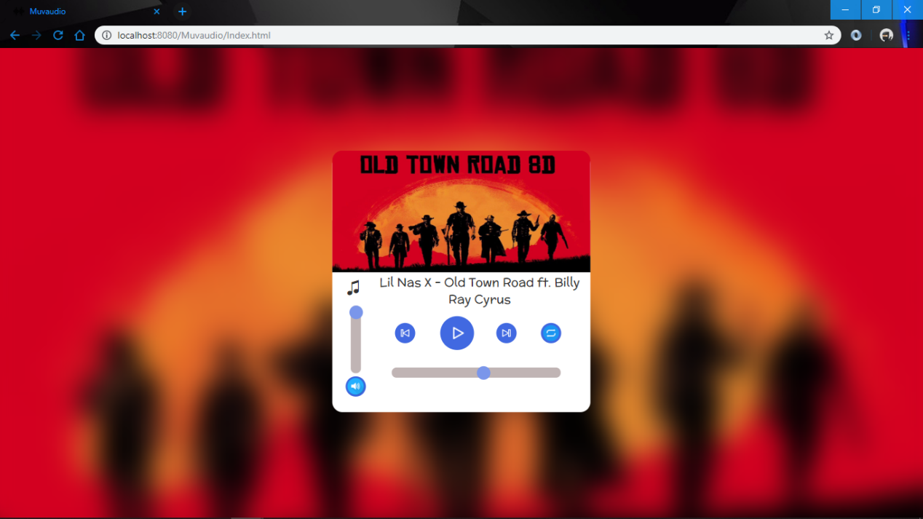

Fig 4.2

**4.3 Volume Bar**

Volume Bar is a vertical progress bar programmed to control the volume of the audio player through the movement of the draggable thumb on the progress bar.The volume bar has been calibrated to reach maximum volume at the top end of progress bar.A alert message is designed to appear if it is tried to increase the volume after max volume.The volume bar is also connected to the keyboard arrow keys and the mute/unmute button.When the volume is decreased to zero the button is changed to show mute button.

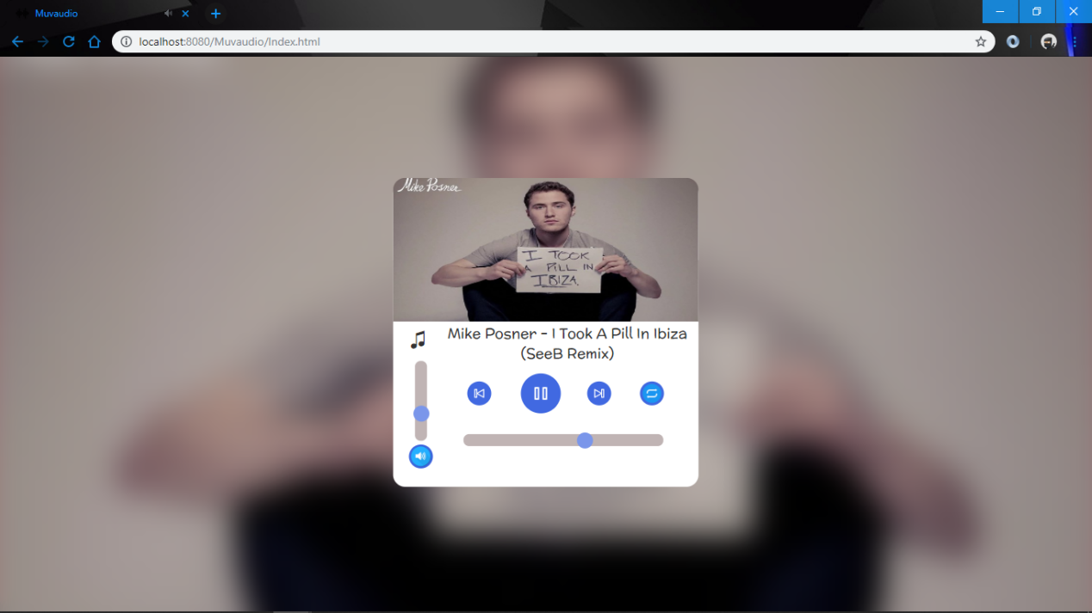

**Fig 4.3**

**4.4 Mute/Unmute**

Mute/Unmute button is designed to toggle between mute sound and unmute sound.It is also linked to the keyboard button ‘m’ which can be uesd to toggle between mute and unmute.

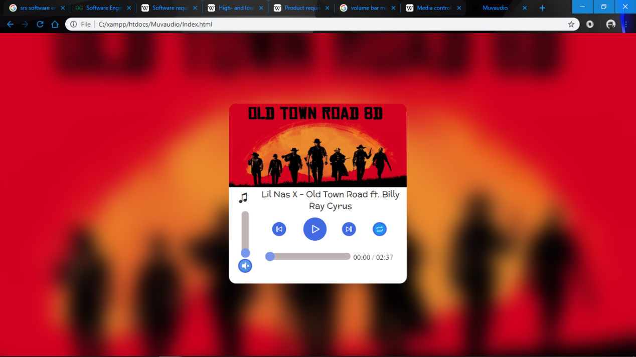

Fig 4.4

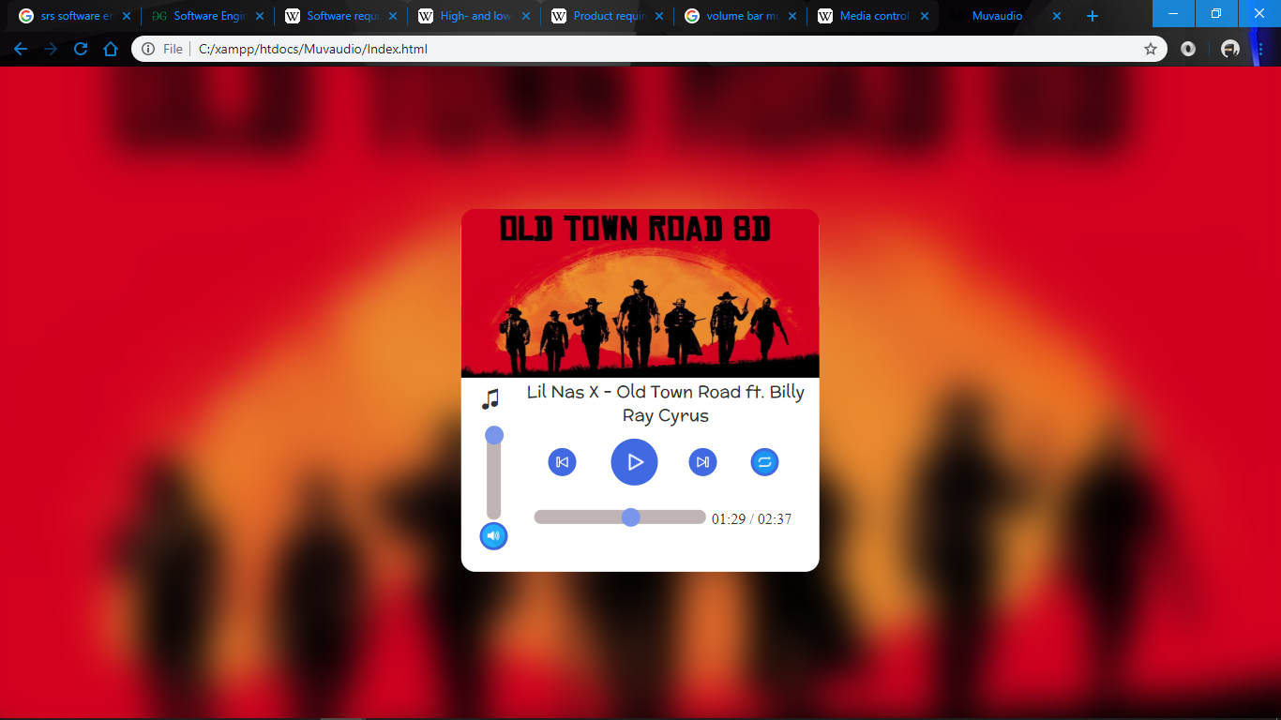

**Fig 4.5**

**4.5 Play/Pause**

Play and pause button is designed to toggle between play and pause./the button is used to control the current playing song.The button is bound to the spacebar that can be used to toggle between the buttons.

**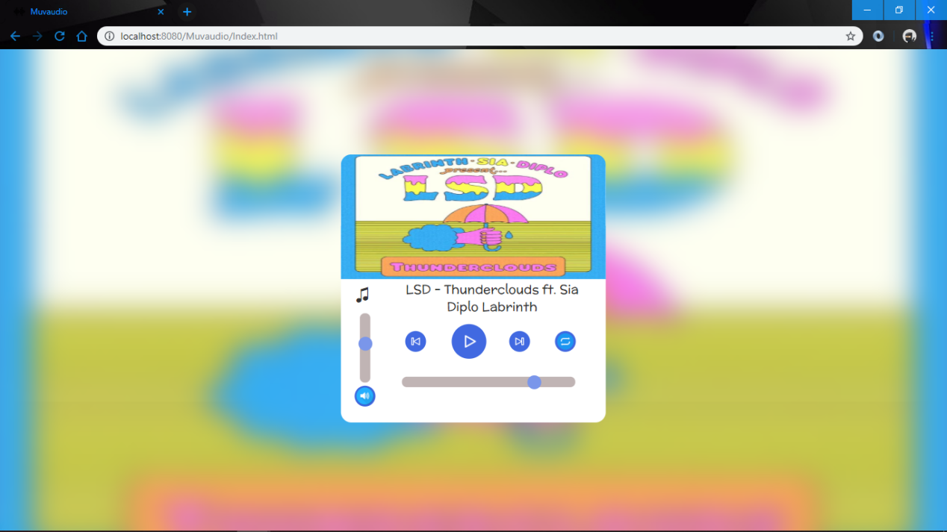**

Fig 4.6

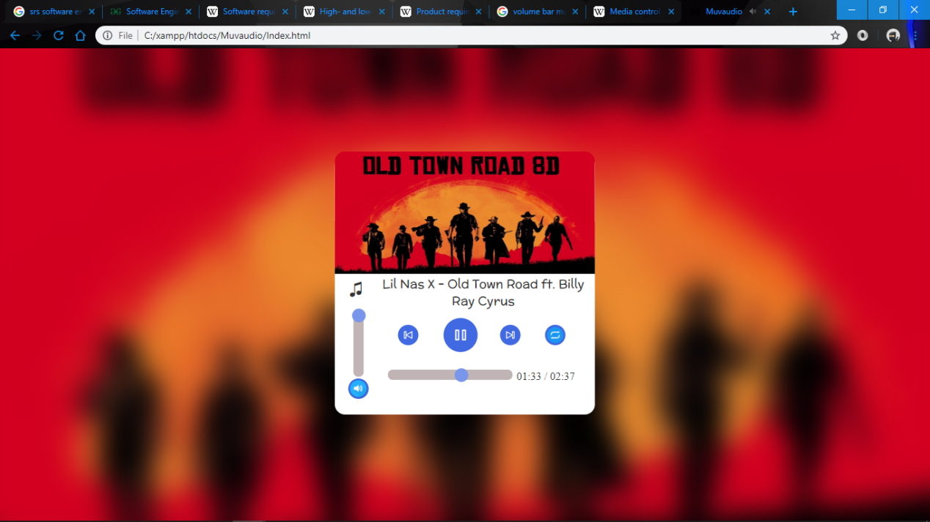

Fig 4.7

**4.6 Repeat**

The Repeat button has been configured to three different modes namely: Repeat Playlist,Repeat Song and Repeat Shuffle.

**4.6.1 Repeat Playlist**

Repeat Playlist is the default setting of the Repeat button.It causes the the playlist to loop after the completion of last song on the playlist.The loop is set to move to next song after completion of previous song. The first song is played after the last song in the playlist is completed.

**4.6.2 Repeat Song**

Repeat Song is the second toggle option in the Repeat button.It is used to loop a single song.The song restarts again after the completion of the song.

**4.6.3 Repeat Shuffle**

Repeat Shuffle is the third and last toggle option of the Repeat button.It is used to randomize the next song to be played from the playlist.The shuffle Repeat Shuffle is used to loop to playlist while the next song to be played is randomly selected from the playlist.

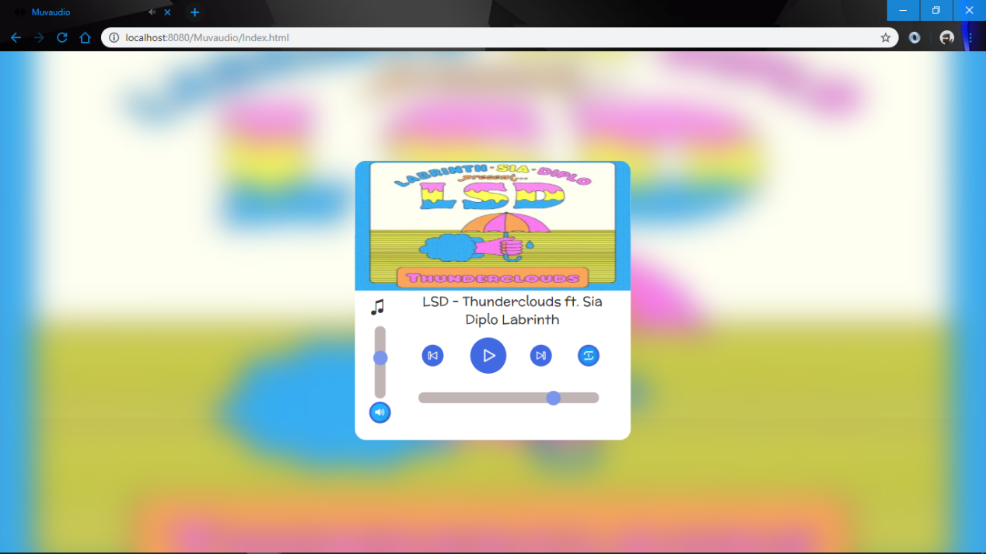

**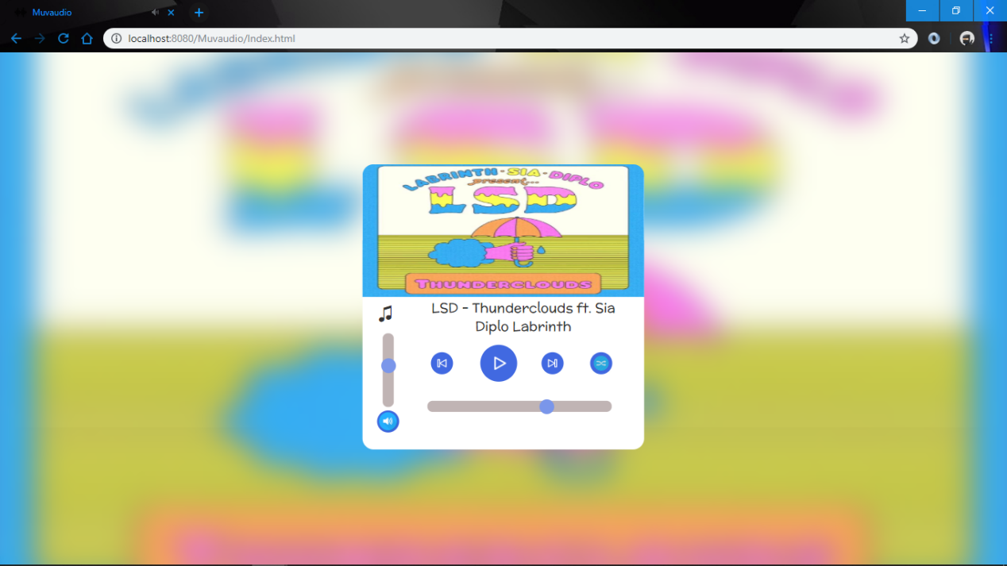**Fig 4.8

Fig 4.8

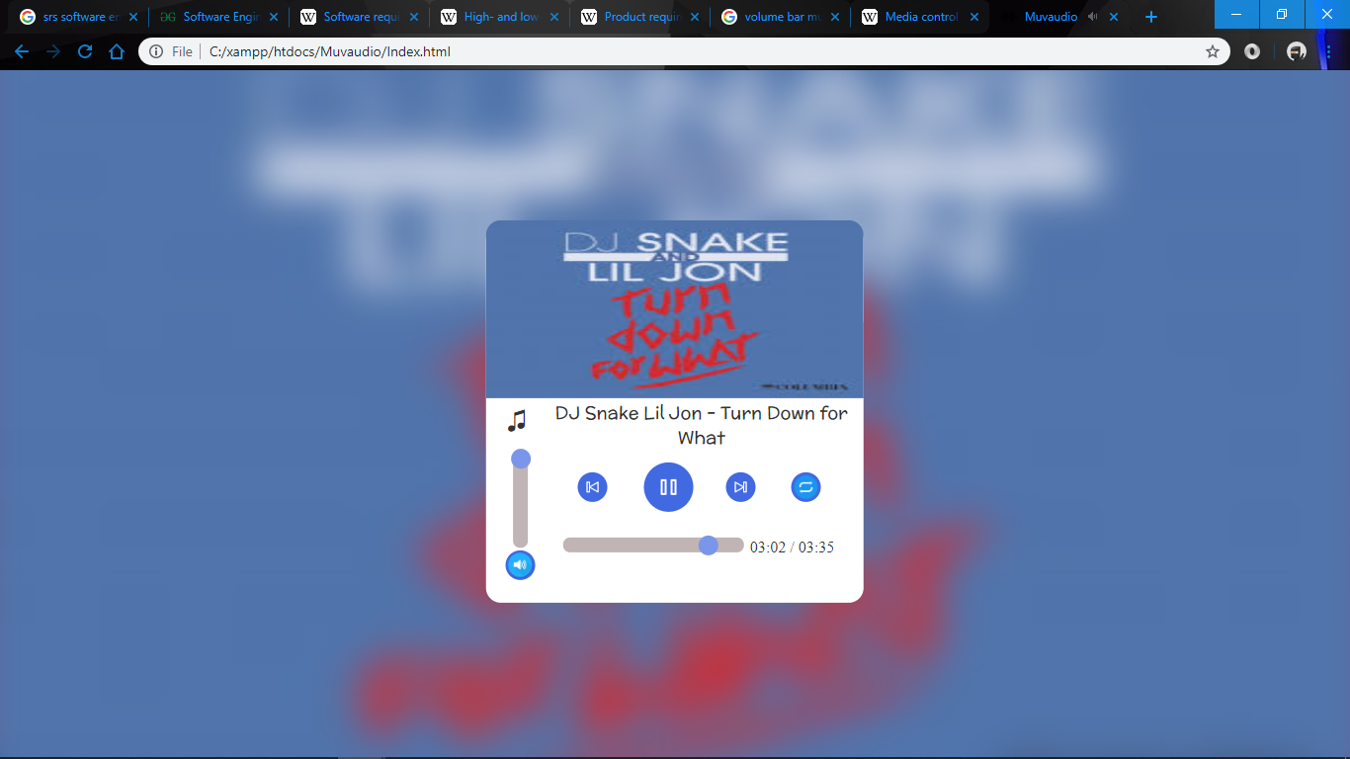Fig 4.9

**4.7 Playlist**

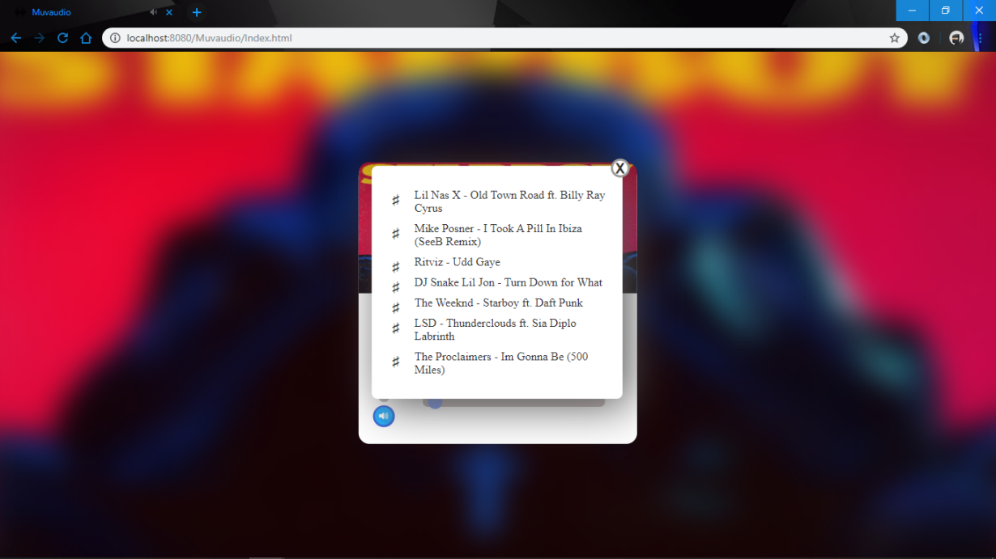A playlist is a list of video or audio files that can be played back on a media player either sequentially or in a shuffled order. In its most general form, an audio playlist is simply a list of songs, but sometimes a loop.

Fig 4.10

**4.8 Download**

Download button has been embedded to the Muvaaudio music player which enables the users to download one song at a time from the playlist using the List button.

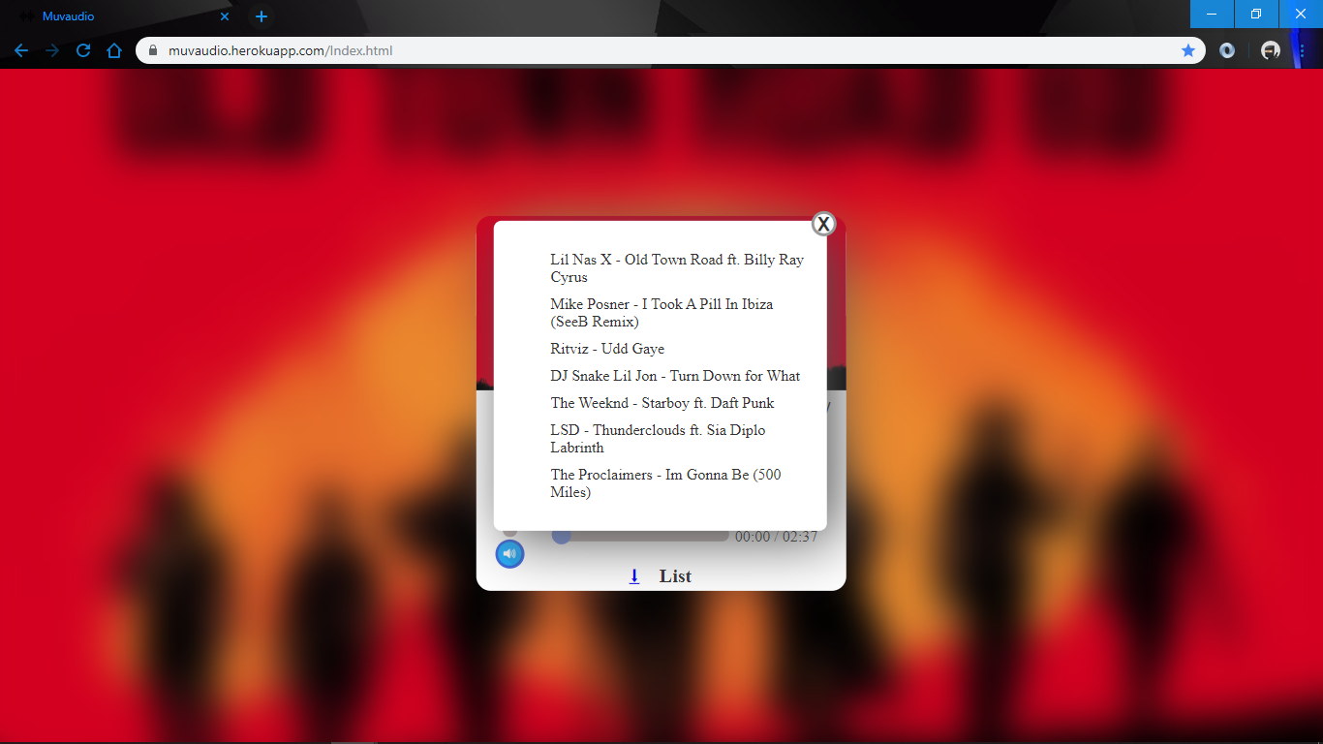

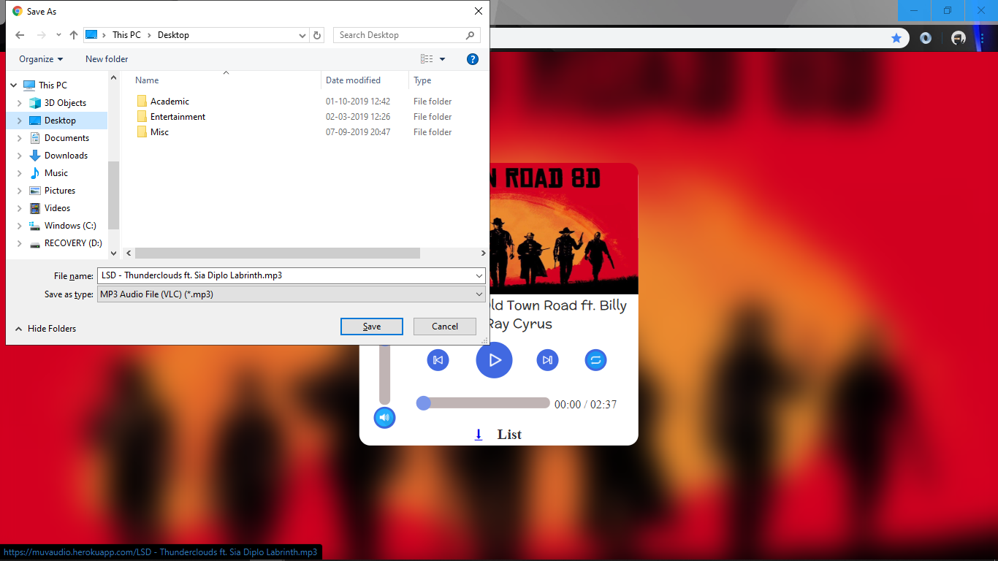Fig 4.11

Fig 4.12

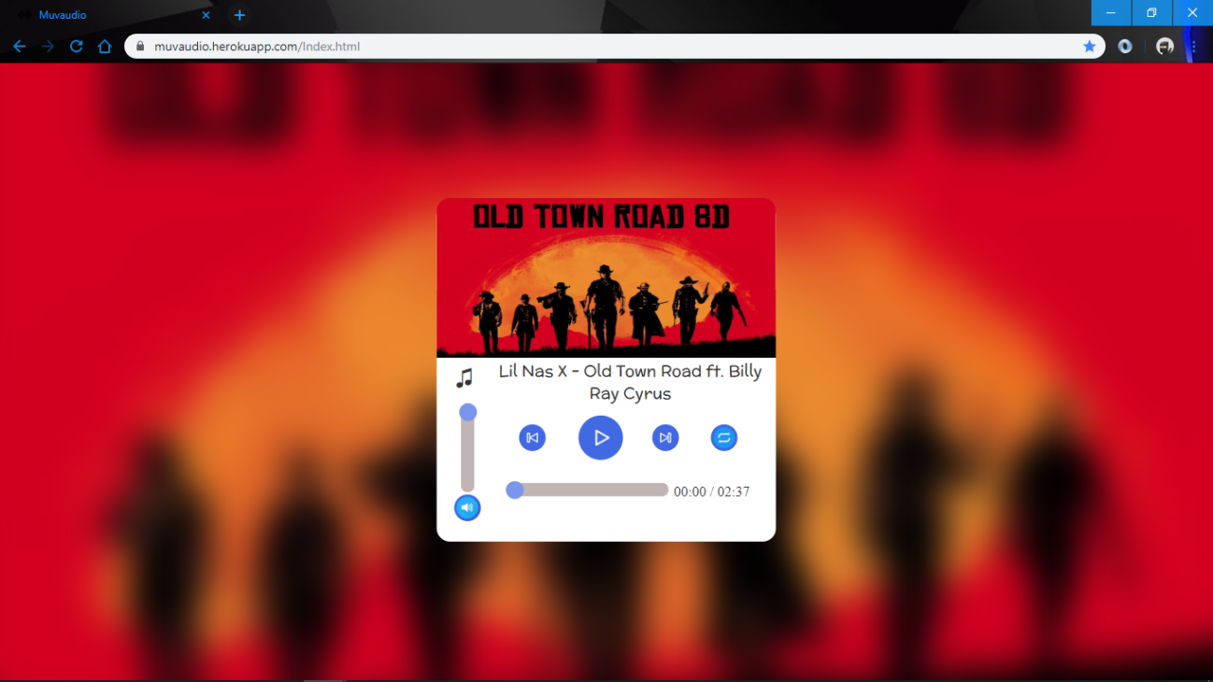**4.9 Heroku Static Site Hosting**

**Fig 4.13**

The music player is programmed to run on html.The music player is run by loading the Index.html file.The site can be run by simply opening the Index.html file in the browser it can also be run locally on localhost using a loopback network interface. But in the above mentioned cases the site can only be run locally on the system.

However by using a web hosting site we can run the website on any system.For this project Heroku web hosting service is used.To host the site using an existing account:

We can trick Heroku to deploy a static site by including 1 dynamic file.The index.php file will be served by Heroku before Index.html. We need to make the browser redirect from index.php to Index.html.Then the command line tool called git is used to initialize or create a version of the site you want to deploy.

**Chapter-5 Conclusion**

It was a wonderful learning experience for me while working on this project. This project took me through the various phases of project development and gave me a real insight into the world of software engineering. The joy of working and the thrill involved while tackling the various problems and challenges gave me a feel of developers industry. It was due to this project I came to know how professional software is designed. The project works fine but there is a lot of scope of improvement. With the rapidly changing and growing technology and innovations in the world I hope to keep working on this project.Using the experience and skill gained from this project development I look forward to continue working with these tools.This Music Player can lead forward to a full fledged audio and video player live website which is what the next goal will be.

**Chapter-6 Bibliography**

* Npmjs.com
* Medium.com
* Expressjs.com
* Mobx.js.org
* Openjs.com
* Wikipedia.org
* TutorialsTeacher.com
* Codingelements.com
* Coursera.org
* Guru99.com
* W3schools.com
* Geeksforgeeks.org
* Jquery.com
* Youtube.com
* Vectorstock.com
* Apachefriends.org
* Stackoverflow.org
* Various open source pdf and published articles available on the internet